Name: Buttery Ham

age: young

gender: male

personality: Likes cute things, likes to compete in fair fights, dislikes long plans and uses instincts a lot. Buttery Ham mostly cares about having fun and joking around with others.

appearance: A hamster

backstory: Trained by fif fywn lu and eventually challenging asta and losing

rank: A+

strength: uses a laser blade (think moonlight blade) on left and a cannon that can be equipped at any time on the other hand.

interaction with main character: meets him later after Shawdos of Ra was introduced. He liked the main character after shooting magic at him and him teleporting. He also caught interest in Shin Shining after meeting the main character thinking he looks cool.

likes: Ham likes strong, carefree, and honest people. Likes fast things.

Neoroy, asta, shin shining

dislikes: Xeliah, Erica blades anyone that is to serious or anyone that is tricky.

habits: Usually around shados or neoroy and likes to joke around with them.

goals: Wants to improve and become as strong as Asta.

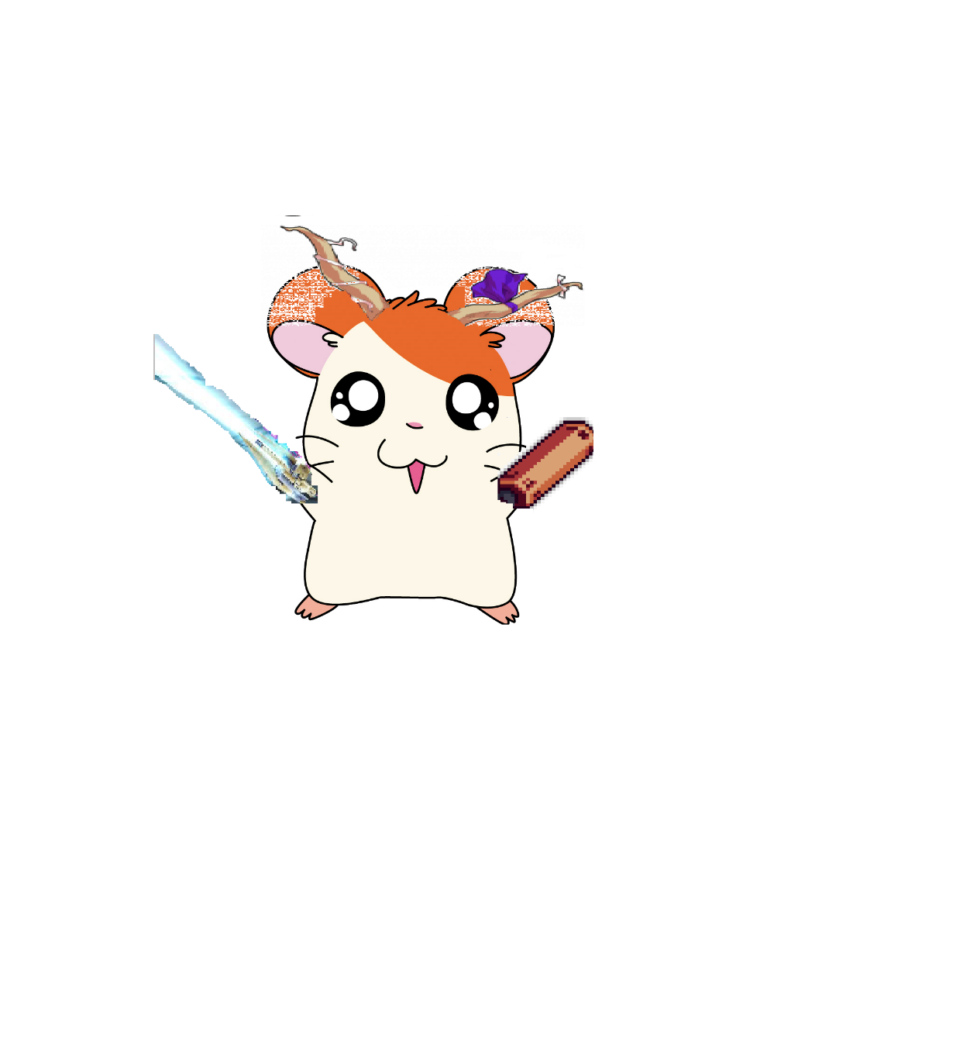

character inspiration: Joey mix with a hamster

